ACKNOWLEDGMENT

I express thanks and gratitude to Mr. Srinivas H.O.D computer science department, St.Mary’s College for his encouraging support and guidance in carrying out the project.

I would like to express gratitude and indebtedness to Mr.Murali for his valuable advice and guidance without which the Criminal Security System project would not have seen the light of the day.

I thank Mr.Naresh, project guide, Naresh Technology for his insistence on good programming technique, which helped us to design and develop a successful model of Paper Less Hospital.

TABLE OF CONTENTS

- Abstract
- Introduction
- System Analysis
4. System Design
  - Project Modules
  - Data Dictionary
  - Data Flow Diagrams
  - Hardware And Software Requirements
- Coding
- Technical Notes
  - Implementation
  - Introduction to HTML
  - Introduction to Java
- Output screens
8. Scope Of The Study
9. Resurch And Methology
10. Future Scope
11. Conclusion
12. Bibliography

1. ABSTRACT

Criminal Securiy System is the software aimed at providing a wide range of access to the administrator in managing and monitoring the requirment registered by the Student regarding the problems they face in accessing the connections extended by defance deparment.

The administrator can even maintain the record of the criminal in the organization in allocating the unique id . This intranet-based application provides system a centralized view of the things maintained in the software depending on the privileges assigned by the administrator accordingly.

In this, admin can upload the details of criminal any time in database by entering criminal’s thumb impression and his basic contact details.Admin can now hide important data also in this application.

INTRODUCTION
Criminal Security System is a application which is used for defance deparment.In this application admin can upload the details of criminal with his thumb impression and his basic contact details in the database.In Future if anywhere any activity is happened then admin take that place’s thumb impression and through this he can search the regarding criminal records.In this application admin can also hide important infromation using the latest technologies i.e. stanography.It is really very safe method.we have also include compression or decompression technique so that important data may be safe by attacing the virus. If image are not identify cleary then we use zoom,contrast etc method to clarify the image .

OBJECTIVE OF THE PROJECT

The main objectives of using Relational Database Management System are as follows: -

- CONTROL REDUNDANCY : The System should identify existence of common data and avoid duplicate recording relationships of pointers should be used to locate data which are used many times selective redundancy is sometimes allowed to improve performance or far better reliability.

- DATA INTEGRITY : Consistency of data values and relationships must be preserved in order to achieve this the system must ensure validity of data by using good editing, synchronize updating and propagating changes to other related data element it also involves maintaining audit trails to enable recovery if errors are deleted.

- DATA SECURITY : This is concerned with protecting access to data protection is needed at many levels for access, modification, deletion or display access restriction may be for individual data items or group of items.

- DATABASE PERFORMANCE : The system should be able to provide timely information as required. The cost of storing and retrieving the data should be commensurate with the value of information provided.

- MANAGEMENT CONTROL : As the dependence of an organization on a data base increases positive management controls should be exercised over addition, deletion, changes and disposition of data must be protected to start legal accounting and auditing requirements.

The aim of this project i.e. Criminal Securiy Systema ll about defance deparment from anywhere, anytime. The extra feature involved in our audio stanografy feature hat it is secured in a way that we can hide important data in a audio file by entering the password and next time we can decode by entering the same password.

Main Objectives are :-
- First of all agent have to upload basic information of criminal with their thumb impression
- Whenever we have to search details of criminal then we can search criminal with their record.
- We can also check criminal record with their thumb impression.
- There are one extra feature included in my project i.e. Steganography.
- We can share data using Audio Steganography so that the chance’s of data hiking may reduces.
- We can also zip or Unzip folder .
- To be familiar with audio steganography techniques.
- To be completely familiar with data compression and decompression of data.
- Also this project makes us familiar with the thumb impression algorithm.

3. SYSTEM ANALYSIS

System Analysis is first stage according to System Development Life Cycle model. This System Analysis is a process that starts with the analyst.
Analysis is a detailed study of the various operations performed by a system and their relationships within and outside the system. One aspect of analysis is defining the boundaries of the system and determining whether or not a candidate should consider other related systems. During analysis, data is collected from the available files, decision points, and transactions handled by the present system.

Logical system models and tools are used in analysis. Training, experience, and common sense are required for collection of the information needed to do the analysis.

3.4 REQURIEMENTS ANALYSIS

The requirement phase basically consists of three activities:

1. Requirement Analysis
2. Requirement Specification
3. Requirement Validation

3.5 REQUIREMENT SPECIFICATION

Specification Principles:

Software Requirements Specification plays an important role in creating quality software solutions. Specification is basically a representation process. Requirements are represented in a manner that ultimately leads to successful software implementation.
Requirements may be specified in a variety of ways. However there are some guidelines worth following: -
- Representation format and content should be relevant to the problem
- Information contained within the specification should be nested
- Diagrams and other notational forms should be restricted in number and consistent in use.
- Representations should be revisable.

Software Requirements Specifications:

The software requirements specification Criminal Security System is at the culmination of the analysis task. The function and performance allocated to the software as a part of system engineering are refined by establishing a complete information description, a detailed functional and behavioral description, and indication of performance requirements and design constraints, appropriate validation criteria and other data pertinent to requirements.
An outline of the Software Requirements Specification:
A simplified outline can be given for the framework of the specifications. This is according to the IEEE Standards.

3.6 FEASIBILITY STUDY

All projects are feasible, given unlimited resources and infinite time. But the development of software Criminal Security System plagued by the scarcity of resources and difficult delivery rates. It is both necessary and prudent to evaluate the feasibility of a project at the earliest possible time.
Three key considerations are involved in the feasibility analysis.

Economic Feasibility:
Technical Feasibility:
Operational Feasibility:

4. SYSTEM DESIGN

The most creative and challenging phase of the life cycle is system design. The term design describes a final system and the process by which it is developed. It refers to the technical specifications that will be applied in implementations of the candidate system. The design may be defined as “the process of applying various techniques and principles for the purpose of defining a device, a process or a system with sufficient details to permit its physical realization”.

The designer’s goal is how the output is to be produced and in what format. Samples of the output and input are also presented. Second input data and database files have to be designed to meet the requirements of the proposed output. The processing phases are handled through the program Construction and Testing. Finally, details related to justification of the system and an estimate of the impact of the candidate system on the user and the organization are documented and evaluated by management as a step toward implementation.
The importance of software design can be stated in a single word “Quality”. Design provides us with representations of software that can be assessed for quality. Design is the only way where we can accurately translate a customer’s requirements into a complete software product or system. Without design we risk building an unstable system that might fail if small changes are made. It may as well be difficult to test, or could be one who’s quality can’t be tested. So it is an essential phase in the development of a software product.
4.1 Project Modules
Different Modules In Computerized System

Module 1: Password Module
In this module, Admin enters a password and the software checks its validity. If the password is valid then he is allowed to enter, otherwise “Invalid User/Password” message is displayed. Different data access rights are assigned to admin only.

Module 2: New Criminal Registration Module
In this module new admin can submit the criminal record with thumb impression and his basic contactable details.

Module 3 Add Zip Module
In this module admin can compress the txt file so that it can be safe from virus attact.

Module 4: Unzip Module
In this module, Admin can decompress the zip file for using that file.

Module 5: Stanografy Module
In this module,admin can hide important message into audio file.
Module 7: Matching Module
In this module, admin can match the thumb impression.

4.2 DICTIONARY
The logical characteristics of current systems data stores, including name, description, aliases, contents, and organization, identifies processes where the data are used and where immediate access to information required, Serves as the basis for identifying database requirements during system design.

Uses of Data Dictionary:

- To manage the details in large systems.
- To communicate a common meaning for all system elements.
- To Document the features of the system.
- To facilitate analysis of the details in order to evaluate characteristics
and determine where system changes should be made.
- To locate errors and omissions in the system.

DATAFLOW DIAGRAMS (DFD)

The data flow diagram is used for classifying system requirements to major transformation that will become programs in system design. This is starting point of the design phase that functionally decomposes the required specifications down to the lower level of details. It consists of a series of bubbles joined together by lines.
Bubbles: Represent the data transformations.
Lines: Represents the logic flow of data.

Data can trigger events and can be processed to useful information. System analysis recognizes the central goal of data in organizations. This dataflow analysis tells a great deal about organization objectives are accomplished.

Dataflow analysis studies the use of data in each activity. It documents this finding in DFD’s. Dataflow analysis give the activities of a system from the viewpoint of data where it originates how they are used or hanged or where they go, including the stops along the way from their destination. The components of dataflow strategy span both requirements determination and system’s design. The first part is called dataflow analysis.

As the name suggests, we didn’t use the dataflow analysis tools exclusively for the analysis stage but also in the designing phase with documentation.

NOTATIONS USED IN DATA FLOW DIAGRAMS

The logic dataflow diagrams can be drawn using only four simple notations i.e., special symbols or icons and the annotation that associates them with a specific system. Since the choice of notation we follow, does not affect impede or catalyze the system process; we used three symbols from YOURDON notation and one from Gain and Sarson notation as specified below.

Element References symbols

Data Flow Process

Process

Data Store

Source or Sink

Description:
Process: describes how input data is converted to output
Data
Data Store: Describes the repositories of data in a system

Data Flow: Describes the data flowing between process, Data stores and external entities.
Sources: An external entity causing the origin of data.
Sink: An external entity, which consumes the data.

Context Diagram:

The top-level diagram is often called a “context diagram”. It contains a single process, but it plays a very important role in studying the current system. The context diagram defines the system that will be studied in the sense that it determines the boundaries. Anything that is not inside the process identified in the context diagram will not be part of the system study. It represents the entire software element as a single bubble with input and output data indicated by incoming and outgoing arrows respectively.
Types of data flow diagrams
DFDs are two types
1. Physical DFD
Structured analysis states that the current system should be first understand correctly. The physical DFD is the model of the current system and is used to ensure that the current system has been clearly understood. Physical DFDs shows actual devices, departments, people etc., involved in the current system

- Logical DFD
Logical DFDs are the model of the proposed system. They
Clearly should show the requirements on which the new system
Should be built. Later during design activity this is taken as the
Basis for drawing the system’s structure charts.

4.3 Data flow Diagrams

Data Flow Diagram Level 0

For constructing DFD level 0 diagram for the proposed approach we need two sources one is for “source” and another is for “destination” and a”process”.
0.0
Personal Data
source

Destination

DFD level 0 is the basic data flow process, the main objective is to transfer the data from sender to receiver after encryption.

Data Flow Diagram Level 1
For constructing DFD level 1 we need to identify and draw the process that make the level 0 process in the project for transferring the personal data from source to destinataion, the personal data is first encrypted and processed and later decrypted.

1.0
Encryption
Data

0.0
Secret
Data
2.0
Transmission
Phase

3.0
Decryption

In this data flow diagram, the secret data is send to the encryption phase for embedding the data into the image for generating the carrier image. In the next phase the carrier image is send to the decryption phase through the transmission
phase.The final phase is the decryption phase where the data is extracted from the image and displays the original message.

Data Flow Diagram Level 2
2.0
Transmission
3.0
Decryption
1.0
Encryption
Decryption
Algorithm
Plain
Text
Encryption
Algorithm
Carrier
Image
Plain
Text

The image and the text document are given in the encryption phase .Since we are using the steganographic approach for transferring the message to the destination,the sender sends textas wellas image fileto the primary phase i.e, to encryption phase.The encryption phase uses the encryption algorithm by which the carrier image is generated .The encryption phase generates the carrier image as output.

First level (Student Module)

Pwd, Username Updated Successfully
Logout

Admin
1.0
Login process
2.0
Criminal Record
3.0
Stanografhy
4.0
Matching Alogrithm

If post the problem

table details

CREATE TABLE `login` (
`uname` varchar(50) NOT NULL,
`pwd` varchar(50) default NULL,
PRIMARY KEY (`uname`)
)

CREATE TABLE `user_records` (
`id` bigint(20) NOT NULL auto_increment,
`name` varchar(100) default NULL,
`dob` varchar(100) default NULL,
`gender` varchar(100) default NULL,
`address` varchar(200) default NULL,
`cricase` varchar(100) default NULL,
`location` varchar(100) default NULL,
`state` varchar(100) default NULL,
`thumb_imp` varchar(100) default NULL,
`img_path` varchar(500) default NULL,
PRIMARY KEY (`id`)
)

4.5 HARDWARE AND SOFTWARE REQUIREMENTS

Hard ware Specification:

Processor : Intel P-III based system

Processor Speed : 250 MHz to 833MHz

RAM : 64MB to 256MB

Hard Disk : 2GB to 30GB

Software Specification:

Language : JDK 1.5, Net beans 6.9, Java

Database : My Sql 5.0

Operating System : Any Operating System.

5.CODING

Connectity
/*
* To change this template, choose Tools | Templates
* and open the template in the editor.
*/
package connection;

import java.sql.Connection;
import java.sql.ResultSet;
import java.sql.Statement;
import java.sql.DriverManager;

public class dbConnection {

static Connection con = null;
Statement st = null;
ResultSet rs = null;

/** Creates a new instance of ConnectionBean */
public static Connection makeConnection() {

try {
Class.forName("com.mysql.jdbc.Driver").newInstance();
con = DriverManager.getConnection("jdbc:mysql://localhost/imagesecuritysystem", "root", "root");

} catch (Exception e) {
e.printStackTrace();
}

return con;
}

public static void closeConnection() throws Exception {
if (con != null) {
con.close();
}
}
}
Image Upload Page:
/*
* To change this template, choose Tools | Templates
* and open the template in the editor.
*/

/*
* ImageUpload.java
*
* Created on Feb 21, 2011, 7:14:21 PM
*/
package foreinsickit;

import java.awt.Component;
import java.awt.image.BufferedImage;
import java.awt.image.Raster;
import java.sql.*;
import java.io.*;
import java.util.logging.Level;
import java.util.logging.Logger;
import javax.imageio.ImageIO;
import javax.swing.JFileChooser;
import javax.swing.JOptionPane;

/**
*
* @author Administrator
*/
public class ImageUpload extends javax.swing.JFrame {

String thumPath = null;
String thumIName = null;
private Component Owner;

/** Creates new form ImageUpload */
public ImageUpload() {
initComponents();
}
String currentdir = System.getProperty("user.dir");
String projectPath = currentdir + "\\src\\Image\\";
String thumb_imp_path = currentdir + "\\src\\ThumbImpression\\";
String destPath = projectPath;
PreparedStatement pst = null;
String imgname = null;
String img_name = null;

public ImageUpload(String fname, String name) {
initComponents();
File inputFile1 = new File(fname);
BufferedImage bufferedImage;
try {
bufferedImage = ImageIO.read(inputFile1);
Raster r1 = bufferedImage.getData();
int hi = r1.getHeight();
int wi = r1.getWidth();
if (hi > 500 || wi > 400) {
JOptionPane.showMessageDialog(rootPane, "Please Upload Image Height <= 500 and Width <= 400");
return;
}

} catch (IOException ex) {
Logger.getLogger(ImageUpload.class.getName()).log(Level.SEVERE, null, ex);
}
txtpath.setText(fname);
img_name = name;

}

@SuppressWarnings("unchecked")
// <editor-fold defaultstate="collapsed" desc="Generated Code">
private void initComponents() {

jPanel1 = new javax.swing.JPanel();
jLabel1 = new javax.swing.JLabel();
txtpath = new javax.swing.JTextField();
jButton1 = new javax.swing.JButton();
jButton2 = new javax.swing.JButton();
jLabel2 = new javax.swing.JLabel();
txtname = new javax.swing.JTextField();
jButton3 = new javax.swing.JButton();
jLabel3 = new javax.swing.JLabel();
jLabel4 = new javax.swing.JLabel();
cmbgender = new javax.swing.JComboBox();
txtaddress = new javax.swing.JTextField();
jLabel5 = new javax.swing.JLabel();
jLabel6 = new javax.swing.JLabel();
cmbdd = new javax.swing.JComboBox();
cmbmm = new javax.swing.JComboBox();
cmbyy = new javax.swing.JComboBox();
jLabel8 = new javax.swing.JLabel();
txtlocation = new javax.swing.JTextField();
jLabel9 = new javax.swing.JLabel();
txtstate = new javax.swing.JTextField();
jLabel10 = new javax.swing.JLabel();
jLabel11 = new javax.swing.JLabel();
txtthumimp = new javax.swing.JTextField();
jLabel12 = new javax.swing.JLabel();
jLabel13 = new javax.swing.JLabel();
jLabel14 = new javax.swing.JLabel();
jLabel15 = new javax.swing.JLabel();
jLabel16 = new javax.swing.JLabel();
jButton4 = new javax.swing.JButton();
cmbcase = new javax.swing.JComboBox();

setDefaultCloseOperation(javax.swing.WindowConstants.EXIT_ON_CLOSE);
setTitle("CriminalSecuritySystem");

jPanel1.setBackground(new java.awt.Color(0, 153, 51));

jLabel1.setFont(new java.awt.Font("Times New Roman", 1, 18));
jLabel1.setText("Upload Image");

jButton1.setFont(new java.awt.Font("Times New Roman", 1, 12));
jButton1.setText("Browse");
jButton1.addActionListener(new java.awt.event.ActionListener() {
public void actionPerformed(java.awt.event.ActionEvent evt) {
jButton1ActionPerformed(evt);
}
});

jButton2.setFont(new java.awt.Font("Times New Roman", 1, 12));
jButton2.setText("Upload");
jButton2.addActionListener(new java.awt.event.ActionListener() {
public void actionPerformed(java.awt.event.ActionEvent evt) {
jButton2ActionPerformed(evt);
}
});

jLabel2.setFont(new java.awt.Font("Monospaced", 1, 12));
jLabel2.setText("Name");

jButton3.setFont(new java.awt.Font("Times New Roman", 1, 12));
jButton3.setText("Close");
jButton3.addActionListener(new java.awt.event.ActionListener() {
public void actionPerformed(java.awt.event.ActionEvent evt) {
jButton3ActionPerformed(evt);
}
});

jLabel3.setFont(new java.awt.Font("Monospaced", 1, 12));
jLabel3.setText("Gender");

jLabel4.setFont(new java.awt.Font("Monospaced", 1, 12));
jLabel4.setText("Address");

cmbgender.setModel(new javax.swing.DefaultComboBoxModel(new String[] { "- - - - Select - - - -", "Male", "Female" }));
cmbgender.addActionListener(new java.awt.event.ActionListener() {
public void actionPerformed(java.awt.event.ActionEvent evt) {
cmbgenderActionPerformed(evt);
}
});

jLabel5.setFont(new java.awt.Font("Monospaced", 1, 12));
jLabel5.setText("Upload Image");

jLabel6.setFont(new java.awt.Font("Monospaced", 1, 12));
jLabel6.setText("Date of Birth");

cmbdd.setModel(new javax.swing.DefaultComboBoxModel(new String[] { "DD", "01", "02", "03", "04", "05", "06", "07", "08", "09", "10", "11", "12", "13", "14", "15", "16", "17", "18", "19", "20", "21", "22", "23", "24", "25", "26", "27", "28", "29", "30", "31" }));

cmbmm.setModel(new javax.swing.DefaultComboBoxModel(new String[] { "MM", "Jan", "Feb", "Mar", "Apr", "May", "Jun", "Jul", "Aug", "Sep", "Oct", "Nov", "Dec", " ", " " }));

cmbyy.setModel(new javax.swing.DefaultComboBoxModel(new String[] { "YYYY", "1990", "1991", "1992", "1993", "1994", "1995", "1996", "1997", "1998", "1999", "2001", "2002", "2003", "2004", "2005", "2006", "2007", "2008", "2009", "2010" }));

jLabel8.setFont(new java.awt.Font("Monospaced", 1, 12));
jLabel8.setText("Location");

txtlocation.setText("Jail");

jLabel9.setFont(new java.awt.Font("Monospaced", 1, 12));
jLabel9.setText("State");

jLabel10.setFont(new java.awt.Font("Monospaced", 1, 12));
jLabel10.setText("Case");

jLabel11.setFont(new java.awt.Font("Monospaced", 1, 12));
jLabel11.setText("Upload Thumb Imp");

jLabel12.setFont(new java.awt.Font("Tahoma", 1, 12));
jLabel12.setForeground(new java.awt.Color(255, 0, 51));
jLabel12.setText("*");

jLabel13.setFont(new java.awt.Font("Tahoma", 1, 12));
jLabel13.setForeground(new java.awt.Color(255, 0, 51));
jLabel13.setText("*");

jLabel14.setFont(new java.awt.Font("Tahoma", 1, 12));
jLabel14.setForeground(new java.awt.Color(255, 0, 51));
jLabel14.setText("*");

jLabel15.setFont(new java.awt.Font("Tahoma", 1, 12));
jLabel15.setForeground(new java.awt.Color(255, 0, 51));
jLabel15.setText("*");

jLabel16.setFont(new java.awt.Font("Tahoma", 1, 12));
jLabel16.setForeground(new java.awt.Color(255, 0, 51));
jLabel16.setText("*");

jButton4.setFont(new java.awt.Font("Times New Roman", 1, 12));
jButton4.setText("Browse");
jButton4.addActionListener(new java.awt.event.ActionListener() {
public void actionPerformed(java.awt.event.ActionEvent evt) {
jButton4ActionPerformed(evt);
}
});

cmbcase.setModel(new javax.swing.DefaultComboBoxModel(new String[] { " - - - - - Select - - - - - ", "Kidnapping", "Manslaughter: Involuntary", "Manslaughter: Voluntary", "Medical Marijuana", "MIP: A Minor in Possession", "Money Laundering", "Murder: First-degree", "Murder: Second-degree", "Open Container Law", "Perjury", "Probation Violation", "Prostitution", "Public Intoxication", "Pyramid Schemes", "Racketeering / RICO", "Rape", "Robbery", "Securities Fraud", "Sexual Assault", "Shoplifting", "Solicitation", "Stalking", "Statutory Rape", "Tax Evasion / Fraud", "Telemarketing Fraud", "Theft / Larceny", "Vandalism", "White Collar Crimes", "Wire Fraud", " ", " " }));

javax.swing.GroupLayout jPanel1Layout = new javax.swing.GroupLayout(jPanel1);
jPanel1.setLayout(jPanel1Layout);
jPanel1Layout.setHorizontalGroup(
jPanel1Layout.createParallelGroup(javax.swing.GroupLayout.Alignment.LEADING)
.addGroup(jPanel1Layout.createSequentialGroup()
.addGap(324, 324, 324)
.addComponent(jLabel1, javax.swing.GroupLayout.PREFERRED_SIZE, 131, javax.swing.GroupLayout.PREFERRED_SIZE)
.addContainerGap(400, Short.MAX_VALUE))
.addGroup(javax.swing.GroupLayout.Alignment.TRAILING, jPanel1Layout.createSequentialGroup()
.addContainerGap(397, Short.MAX_VALUE)
.addComponent(jButton3)
.addPreferredGap(javax.swing.LayoutStyle.ComponentPlacement.UNRELATED)
.addComponent(jButton2)
.addGap(316, 316, 316))
.addGroup(jPanel1Layout.createSequentialGroup()
.addContainerGap()
.addGroup(jPanel1Layout.createParallelGroup(javax.swing.GroupLayout.Alignment.LEADING)
.addGroup(jPanel1Layout.createParallelGroup(javax.swing.GroupLayout.Alignment.LEADING)
.addGroup(jPanel1Layout.createSequentialGroup()
.addGroup(jPanel1Layout.createParallelGroup(javax.swing.GroupLayout.Alignment.LEADING)
.addComponent(jLabel8)
.addGroup(jPanel1Layout.createSequentialGroup()
.addComponent(jLabel5)
.addPreferredGap(javax.swing.LayoutStyle.ComponentPlacement.RELATED)
.addComponent(jLabel12, javax.swing.GroupLayout.PREFERRED_SIZE, 13, javax.swing.GroupLayout.PREFERRED_SIZE))
.addGroup(jPanel1Layout.createSequentialGroup()
.addComponent(jLabel2)
.addPreferredGap(javax.swing.LayoutStyle.ComponentPlacement.RELATED)
.addComponent(jLabel13, javax.swing.GroupLayout.PREFERRED_SIZE, 13, javax.swing.GroupLayout.PREFERRED_SIZE)))
.addGap(48, 48, 48))
.addGroup(jPanel1Layout.createSequentialGroup()
.addComponent(jLabel6, javax.swing.GroupLayout.DEFAULT_SIZE, 113, Short.MAX_VALUE)
.addPreferredGap(javax.swing.LayoutStyle.ComponentPlacement.RELATED)
.addComponent(jLabel15)
.addGap(24, 24, 24)))
.addGroup(jPanel1Layout.createSequentialGroup()
.addComponent(jLabel10)
.addPreferredGap(javax.swing.LayoutStyle.ComponentPlacement.RELATED)
.addComponent(jLabel16, javax.swing.GroupLayout.PREFERRED_SIZE, 13, javax.swing.GroupLayout.PREFERRED_SIZE)
.addGap(104, 104, 104)))
.addGroup(jPanel1Layout.createParallelGroup(javax.swing.GroupLayout.Alignment.LEADING, false)
.addComponent(cmbcase, 0, javax.swing.GroupLayout.DEFAULT_SIZE, Short.MAX_VALUE)
.addGroup(jPanel1Layout.createSequentialGroup()
.addComponent(cmbdd, javax.swing.GroupLayout.PREFERRED_SIZE, 68, javax.swing.GroupLayout.PREFERRED_SIZE)
.addGap(2, 2, 2)
.addComponent(cmbmm, javax.swing.GroupLayout.PREFERRED_SIZE, 67, javax.swing.GroupLayout.PREFERRED_SIZE)
.addPreferredGap(javax.swing.LayoutStyle.ComponentPlacement.RELATED)
.addComponent(cmbyy, 0, javax.swing.GroupLayout.DEFAULT_SIZE, Short.MAX_VALUE))
.addComponent(txtname)
.addGroup(jPanel1Layout.createSequentialGroup()
.addComponent(txtpath, javax.swing.GroupLayout.PREFERRED_SIZE, 154, javax.swing.GroupLayout.PREFERRED_SIZE)
.addPreferredGap(javax.swing.LayoutStyle.ComponentPlacement.RELATED)
.addComponent(jButton1))
.addComponent(txtlocation))
.addGap(45, 45, 45)
.addGroup(jPanel1Layout.createParallelGroup(javax.swing.GroupLayout.Alignment.LEADING)
.addComponent(jLabel9)
.addGroup(jPanel1Layout.createSequentialGroup()
.addComponent(jLabel3)
.addPreferredGap(javax.swing.LayoutStyle.ComponentPlacement.RELATED)
.addComponent(jLabel14, javax.swing.GroupLayout.PREFERRED_SIZE, 13, javax.swing.GroupLayout.PREFERRED_SIZE))
.addComponent(jLabel11)
.addComponent(jLabel4))
.addGap(83, 83, 83)
.addGroup(jPanel1Layout.createParallelGroup(javax.swing.GroupLayout.Alignment.LEADING)
.addComponent(cmbgender, 0, 213, Short.MAX_VALUE)
.addGroup(jPanel1Layout.createSequentialGroup()
.addComponent(txtthumimp, javax.swing.GroupLayout.PREFERRED_SIZE, 134, javax.swing.GroupLayout.PREFERRED_SIZE)
.addPreferredGap(javax.swing.LayoutStyle.ComponentPlacement.RELATED)
.addComponent(jButton4))
.addComponent(txtstate, javax.swing.GroupLayout.Alignment.TRAILING, javax.swing.GroupLayout.DEFAULT_SIZE, 213, Short.MAX_VALUE)
.addComponent(txtaddress, javax.swing.GroupLayout.DEFAULT_SIZE, 213, Short.MAX_VALUE))
.addContainerGap())
);
jPanel1Layout.setVerticalGroup(
jPanel1Layout.createParallelGroup(javax.swing.GroupLayout.Alignment.LEADING)
.addGroup(jPanel1Layout.createSequentialGroup()
.addGap(26, 26, 26)
.addComponent(jLabel1)
.addGap(47, 47, 47)
.addGroup(jPanel1Layout.createParallelGroup(javax.swing.GroupLayout.Alignment.BASELINE)
.addComponent(txtpath, javax.swing.GroupLayout.PREFERRED_SIZE, javax.swing.GroupLayout.DEFAULT_SIZE, javax.swing.GroupLayout.PREFERRED_SIZE)
.addComponent(jLabel5)
.addComponent(jButton1)
.addComponent(jLabel12)
.addComponent(jLabel11)
.addComponent(txtthumimp, javax.swing.GroupLayout.PREFERRED_SIZE, javax.swing.GroupLayout.DEFAULT_SIZE, javax.swing.GroupLayout.PREFERRED_SIZE)
.addComponent(jButton4))
.addGroup(jPanel1Layout.createParallelGroup(javax.swing.GroupLayout.Alignment.LEADING, false)
.addGroup(jPanel1Layout.createSequentialGroup()
.addGap(30, 30, 30)
.addGroup(jPanel1Layout.createParallelGroup(javax.swing.GroupLayout.Alignment.BASELINE)
.addComponent(jLabel3)
.addComponent(jLabel14)
.addComponent(cmbgender, javax.swing.GroupLayout.PREFERRED_SIZE, javax.swing.GroupLayout.DEFAULT_SIZE, javax.swing.GroupLayout.PREFERRED_SIZE))
.addGap(37, 37, 37))
.addGroup(javax.swing.GroupLayout.Alignment.TRAILING, jPanel1Layout.createSequentialGroup()
.addPreferredGap(javax.swing.LayoutStyle.ComponentPlacement.RELATED, javax.swing.GroupLayout.DEFAULT_SIZE, Short.MAX_VALUE)
.addGroup(jPanel1Layout.createParallelGroup(javax.swing.GroupLayout.Alignment.BASELINE)
.addComponent(txtname, javax.swing.GroupLayout.PREFERRED_SIZE, javax.swing.GroupLayout.DEFAULT_SIZE, javax.swing.GroupLayout.PREFERRED_SIZE)
.addComponent(jLabel13)
.addComponent(jLabel2))
.addGap(29, 29, 29)))
.addGroup(jPanel1Layout.createParallelGroup(javax.swing.GroupLayout.Alignment.BASELINE)
.addComponent(txtaddress, javax.swing.GroupLayout.PREFERRED_SIZE, javax.swing.GroupLayout.DEFAULT_SIZE, javax.swing.GroupLayout.PREFERRED_SIZE)
.addComponent(jLabel4)
.addComponent(jLabel6)
.addComponent(jLabel15)
.addComponent(cmbdd, javax.swing.GroupLayout.PREFERRED_SIZE, javax.swing.GroupLayout.DEFAULT_SIZE, javax.swing.GroupLayout.PREFERRED_SIZE)
.addComponent(cmbmm, javax.swing.GroupLayout.PREFERRED_SIZE, javax.swing.GroupLayout.DEFAULT_SIZE, javax.swing.GroupLayout.PREFERRED_SIZE)
.addComponent(cmbyy, javax.swing.GroupLayout.PREFERRED_SIZE, javax.swing.GroupLayout.DEFAULT_SIZE, javax.swing.GroupLayout.PREFERRED_SIZE))
.addGap(40, 40, 40)
.addGroup(jPanel1Layout.createParallelGroup(javax.swing.GroupLayout.Alignment.BASELINE)
.addComponent(txtlocation, javax.swing.GroupLayout.PREFERRED_SIZE, javax.swing.GroupLayout.DEFAULT_SIZE, javax.swing.GroupLayout.PREFERRED_SIZE)
.addComponent(jLabel8)
.addComponent(txtstate, javax.swing.GroupLayout.PREFERRED_SIZE, javax.swing.GroupLayout.DEFAULT_SIZE, javax.swing.GroupLayout.PREFERRED_SIZE)
.addComponent(jLabel9))
.addGap(40, 40, 40)
.addGroup(jPanel1Layout.createParallelGroup(javax.swing.GroupLayout.Alignment.BASELINE)
.addComponent(jLabel10)
.addComponent(jLabel16)
.addComponent(cmbcase, javax.swing.GroupLayout.PREFERRED_SIZE, javax.swing.GroupLayout.DEFAULT_SIZE, javax.swing.GroupLayout.PREFERRED_SIZE))
.addPreferredGap(javax.swing.LayoutStyle.ComponentPlacement.RELATED, 104, Short.MAX_VALUE)
.addGroup(jPanel1Layout.createParallelGroup(javax.swing.GroupLayout.Alignment.BASELINE)
.addComponent(jButton2)
.addComponent(jButton3))
.addGap(21, 21, 21))
);

javax.swing.GroupLayout layout = new javax.swing.GroupLayout(getContentPane());
getContentPane().setLayout(layout);
layout.setHorizontalGroup(
layout.createParallelGroup(javax.swing.GroupLayout.Alignment.LEADING)
.addComponent(jPanel1, javax.swing.GroupLayout.DEFAULT_SIZE, javax.swing.GroupLayout.DEFAULT_SIZE, Short.MAX_VALUE)
);
layout.setVerticalGroup(
layout.createParallelGroup(javax.swing.GroupLayout.Alignment.LEADING)
.addComponent(jPanel1, javax.swing.GroupLayout.DEFAULT_SIZE, javax.swing.GroupLayout.DEFAULT_SIZE, Short.MAX_VALUE)
);

pack();
}// </editor-fold>

private void jButton1ActionPerformed(java.awt.event.ActionEvent evt) {
// TODO add your handling code here:
SelectUpload select = new SelectUpload();
dispose();
select.show();
}

private void jButton2ActionPerformed(java.awt.event.ActionEvent evt) {

String path = txtpath.getText();

if (path.equals("")) {
JOptionPane.showMessageDialog(rootPane, "Upload Image field Cannot be Blank Left !!");
return;
}

String name = txtname.getText();
if (name.equals("")) {
JOptionPane.showMessageDialog(rootPane, "Name Field Cannot be Blank Left!!");
return;
}

Object gender = cmbgender.getSelectedItem();
if (gender.equals("- - - - Select - - - -")) {
JOptionPane.showMessageDialog(rootPane, "Please Select The Gender !!");
return;
}

Object dd = cmbdd.getSelectedItem();
Object mm = cmbmm.getSelectedItem();
Object yy = cmbyy.getSelectedItem();
if (dd.equals("DD") || mm.equals("MM") || yy.equals("YYYY")) {
JOptionPane.showMessageDialog(rootPane, "Please Select The DOB !!");
return;
}
String dob = dd.toString() + "-" + mm.toString() + "-" + yy.toString();

String address = txtaddress.getText();

String location = txtlocation.getText();
String state = txtstate.getText();
Object cricase = cmbcase.getSelectedItem();
if (cricase.equals("- - - - - Select - - - - -")) {
JOptionPane.showMessageDialog(rootPane, "Please Select Name of Case");
return;
}
String thumpimp = txtthumimp.getText();
if (thumpimp.equals("")) {
JOptionPane.showMessageDialog(rootPane, "Please open Crimnal Thumb Impression");
return;
}

try {
File inputfile = new File(path);
File outputfile = new File(destPath + img_name);
BufferedInputStream bis = new BufferedInputStream(new FileInputStream(inputfile), 4096);
BufferedOutputStream bos = new BufferedOutputStream(new FileOutputStream(outputfile), 4096);
int c;
while ((c = bis.read()) != -1) {
bos.write(c);
}
bos.close();
bis.close();

} catch (FileNotFoundException ex) {
//ex.printStackTrace();
} catch (IOException ex) {
//ex.printStackTrace();
}

try {
File inputfile = new File(thumpimp);
File outputfile = new File(thumb_imp_path + thumIName);
BufferedInputStream bis = new BufferedInputStream(new FileInputStream(inputfile), 4096);
BufferedOutputStream bos = new BufferedOutputStream(new FileOutputStream(outputfile), 4096);
int c;
while ((c = bis.read()) != -1) {
bos.write(c);
}
bos.close();
bis.close();

} catch (FileNotFoundException ex) {
//ex.printStackTrace();
} catch (IOException ex) {
//ex.printStackTrace();
}

//save image in database
try {
Connection con = connection.dbConnection.makeConnection();

String sql = "insert into user_records (name,gender,address,img_path,dob,cricase,location,state,thumb_imp) values(?,?,?,?,?,?,?,?,?)";
pst = con.prepareStatement(sql);
pst.setString(1, name);
pst.setString(2, gender.toString());
pst.setString(3, address);
pst.setString(4, img_name);
pst.setString(5, dob);
pst.setString(6, cricase.toString());
pst.setString(7, location);
pst.setString(8, state);
pst.setString(9, thumIName);

int i = pst.executeUpdate();
if (i > 0) {
javax.swing.JOptionPane.showMessageDialog(null, "New Records Successfully Saved");
txtpath.setText("");
txtname.setText("");
cmbgender.setSelectedIndex(0);
cmbdd.setSelectedIndex(0);
cmbmm.setSelectedIndex(0);
cmbyy.setSelectedIndex(0);
txtaddress.setText("");
txtlocation.setText("");
txtstate.setText("");
txtthumimp.setText("");
cmbcase.setSelectedIndex(0);

} else {
javax.swing.JOptionPane.showMessageDialog(null, "New Records Not Saved");
}
txtpath.setText("");
txtname.setText("");
cmbgender.setSelectedIndex(0);
txtaddress.setText("");
} catch (Exception e) {
e.printStackTrace();
}
}

private void jButton3ActionPerformed(java.awt.event.ActionEvent evt) {
// TODO add your handling code here:

CaptureImage cp = new CaptureImage();
//Home cp = new Home();
dispose();
cp.show();
}

private void cmbgenderActionPerformed(java.awt.event.ActionEvent evt) {
// TODO add your handling code here:
}

private void jButton4ActionPerformed(java.awt.event.ActionEvent evt) {
// TODO add your handling code here:
String thumName[] = fileChooser().split(":-");
txtthumimp.setText(thumName[0]);
thumIName = thumName[1];
}

/**
* @param args the command line arguments
*/
public static void main(String args[]) {
java.awt.EventQueue.invokeLater(new Runnable() {

public void run() {
new ImageUpload().setVisible(true);
}
});
}
// Variables declaration - do not modify
private javax.swing.JComboBox cmbcase;
private javax.swing.JComboBox cmbdd;
private javax.swing.JComboBox cmbgender;
private javax.swing.JComboBox cmbmm;
private javax.swing.JComboBox cmbyy;
private javax.swing.JButton jButton1;
private javax.swing.JButton jButton2;
private javax.swing.JButton jButton3;
private javax.swing.JButton jButton4;
private javax.swing.JLabel jLabel1;
private javax.swing.JLabel jLabel10;
private javax.swing.JLabel jLabel11;
private javax.swing.JLabel jLabel12;
private javax.swing.JLabel jLabel13;
private javax.swing.JLabel jLabel14;
private javax.swing.JLabel jLabel15;
private javax.swing.JLabel jLabel16;
private javax.swing.JLabel jLabel2;
private javax.swing.JLabel jLabel3;
private javax.swing.JLabel jLabel4;
private javax.swing.JLabel jLabel5;
private javax.swing.JLabel jLabel6;
private javax.swing.JLabel jLabel8;
private javax.swing.JLabel jLabel9;
private javax.swing.JPanel jPanel1;
private javax.swing.JTextField txtaddress;
private javax.swing.JTextField txtlocation;
private javax.swing.JTextField txtname;
private javax.swing.JTextField txtpath;
private javax.swing.JTextField txtstate;
private javax.swing.JTextField txtthumimp;
// End of variables declaration

public String fileChooser() {

String path = null;
String p_name = null;
JFileChooser chooser = new JFileChooser();
chooser.setFileSelectionMode(JFileChooser.FILES_AND_DIRECTORIES);
if (JFileChooser.APPROVE_OPTION == chooser.showOpenDialog(Owner)) {
path = chooser.getSelectedFile().getPath();
p_name = chooser.getSelectedFile().getName();

}
return path + ":-" + p_name;

}
}

Stanography:
/*
* To change this template, choose Tools | Templates
* and open the template in the editor.
*/
package foreinsickit;

/**
*
* @author Kamal Kant
*/
import java.util.logging.Level;
import java.util.logging.Logger;
import javax.swing.*;
import java.awt.*;
import java.awt.event.*;
import java.net.*;
import java.io.*;
import java.util.*;
import sun.audio.*;
import java.applet.*;
import java.math.*;

class mainframe extends JFrame implements ActionListener, Runnable {

JLabel Lfilename, Lmessage, Ldesign, Ltitle;
JButton Bplay, Bopen, Bsave, Bstop, Bencrypt, Bdecrypt, Bsend, Bclear;
JTextArea Amessage;
JTextField Tfilename;
Icon Iplay, Iopen, Istop, Isave;
String Ekey, Dkey, address, name;
JFileChooser filechooser;
File Ofilename, Sfilename, tempfilename;
InetAddress ipaddress;
int Copened, Cencrypt, Cdecrypt, Cplay, Cstop, Csave;
InputStream ins;
AudioStream as;
Thread t;

public mainframe() throws Exception {

// frame

super("Steganography Using Audio");
Container con = getContentPane();
con.setLayout(null);

// Basic

Copened = 0;
Cencrypt = 0;
Cdecrypt = 0;
Cplay = 0;
Csave = 0;
Cstop = 0;

t = new Thread(this);
t.start();

// Icons

Iplay = new ImageIcon("play.jpg");
Isave = new ImageIcon("save.jpg");
Iopen = new ImageIcon("open.jpg");
Istop = new ImageIcon("stop.jpg");

// file chooser

filechooser = new JFileChooser();
filechooser.setFileSelectionMode(JFileChooser.FILES_ONLY);

// comp

Ltitle = new JLabel("Steganography Using Audio");
Ldesign = new JLabel("");
Lfilename = new JLabel("File Name ");
Lmessage = new JLabel("Message ");
Bplay = new JButton("p", Iplay);
Bopen = new JButton("o", Iopen);
Bsave = new JButton("s", Isave);
Bstop = new JButton("s", Istop);
Bclear = new JButton("Clear");
Bencrypt = new JButton("Encoding");
Bdecrypt = new JButton("Decoding");
Bsend = new JButton("");
Amessage = new JTextArea();
Tfilename = new JTextField();

// tool tips

Tfilename.setToolTipText("Opened filename");
Bplay.setToolTipText("play");
Bopen.setToolTipText("open");
Bsave.setToolTipText("save");
Bstop.setToolTipText("stop");

Tfilename.setEditable(false);

// Bounds

Ltitle.setBounds(300, 30, 250, 25);
Lfilename.setBounds(100, 100, 100, 25);
Tfilename.setBounds(100, 125, 230, 25);
Lmessage.setBounds(450, 100, 100, 25);
Amessage.setBounds(450, 125, 300, 220);
Bclear.setBounds(450, 370, 80, 22);
Bplay.setBounds(100, 200, 50, 25);
Bstop.setBounds(160, 200, 50, 25);
Bopen.setBounds(220, 200, 50, 25);
Bsave.setBounds(280, 200, 50, 25);
Bencrypt.setBounds(100, 250, 110, 25);
Bdecrypt.setBounds(220, 250, 110, 25);
Bsend.setBounds(160, 300, 110, 25);
Ldesign.setBounds(350, 420, 400, 50);

// add

con.add(Ltitle);
con.add(Ldesign);
con.add(Lfilename);
con.add(Tfilename);
con.add(Lmessage);
con.add(Amessage);
con.add(Bclear);
con.add(Bplay);
con.add(Bopen);
con.add(Bsave);
con.add(Bstop);
con.add(Bencrypt);
con.add(Bdecrypt);
con.add(Bsend);

// actionListener

Bclear.addActionListener(this);
Bplay.addActionListener(this);
Bopen.addActionListener(this);
Bsave.addActionListener(this);
Bstop.addActionListener(this);
Bencrypt.addActionListener(this);
Bdecrypt.addActionListener(this);
Bsend.addActionListener(this);

} // constr of mainframe

public void run() {
try {
recv r = new recv();
} catch (Exception e) {
System.out.println(e);
}
}

public void Audioencrypt(String message, File file, int key) throws
Exception {
byte b[] = new byte[1];
BigInteger Abi, Mbi;
int k, k1;
InputStream ins = new FileInputStream(file);
OutputStream outs = new FileOutputStream(new File("D:/pop8.wav"));
for (int c = 0; c < key; c++) {
int ch = ins.read();
outs.write(ch);
}
int len = message.length();
byte mess[] = new byte[1];
char chmess[] = new char[len + 1];
k = k1 = 0;
for (int i = 0; i <= len; i++) {
message.getChars(0, len, chmess, 0);
if (i == 0) {
BigDecimal bd = new BigDecimal(len);
BigInteger Blen = bd.toBigInteger();
String Slen = Blen.toString(2);
char Clen[] = new char[Blen.bitLength()];
Slen.getChars(0, Blen.bitLength(), Clen, 0);
for (int j = 0; j <= 7; j++) {
if (j == 0) {
for (k = 0; k < 8 - Blen.bitLength(); k++) {
int n = ins.read(b);
Abi = new BigInteger(b);
String Aby = Abi.toString(2);
int Alen = Abi.bitLength();
if (b[0] < 0) {
Alen++;
}
char Ach[] = new char[Alen + 1];
Aby.getChars(0, Alen, Ach, 0);

if (b[0] == 0) {
} else {
if (Ach[Alen - 1] == '1') {
if (Alen == Abi.bitLength()) {
BigInteger bi = new BigInteger("11111110", 2);
BigInteger big = Abi.and(bi);
b = big.toByteArray();
} else {
BigInteger bi = new BigInteger("-1", 2);
BigInteger big = Abi.subtract(bi);
b = big.toByteArray();
}
}
outs.write(b);
}
} //for loop k
j = j + k - 1;
} // if of j
else {
int n = ins.read(b);
Abi = new BigInteger(b);
String Aby = Abi.toString(2);
int Alen = Abi.bitLength();
if (b[0] < 0) {
Alen++;
}
char Ach[] = new char[Alen + 1];
Aby.getChars(0, Alen, Ach, 0);
if (b[0] == 0) {
Alen = 1;
}
if (Clen[j - k] == '0' && Ach[Alen - 1] == '1') {
if (Alen == Abi.bitLength()) {
BigInteger bi = new BigInteger("11111110", 2);
BigInteger big = Abi.and(bi);
b = big.toByteArray();
} else {
BigInteger bi = new BigInteger("-1", 2);
BigInteger big = Abi.subtract(bi);
b = big.toByteArray();
}
} else if (Clen[j - k] == '1' && Ach[Alen - 1] == '0') {
if (Alen == Abi.bitLength()) {
BigInteger bi = new BigInteger("1", 2);
BigInteger big = Abi.add(bi);
b = big.toByteArray();
} else {
BigInteger bi = new BigInteger("-1", 2);
BigInteger big = Abi.add(bi);
b = big.toByteArray();
}

}
outs.write(b);
} // end else

} // for loop j

} // end of if
else {
String slen = String.valueOf(chmess[i - 1]);
byte blen[] = slen.getBytes();
BigInteger Blen = new BigInteger(blen);
String Slen = Blen.toString(2);
char Clen[] = new char[Blen.bitLength()];
Slen.getChars(0, Blen.bitLength(), Clen, 0);
for (int j = 0; j <= 7; j++) {
if (j == 0) {
for (k1 = 0; k1 < 8 - Blen.bitLength(); k1++) {
int n = ins.read(b);
Abi = new BigInteger(b);
String Aby = Abi.toString(2);
int Alen = Abi.bitLength();
if (b[0] < 0) {
Alen++;
}
char Ach[] = new char[Alen + 1];
Aby.getChars(0, Alen, Ach, 0);
if (b[0] == 0) {
} else {
if (Ach[Alen - 1] == '1') {
if (Alen == Abi.bitLength()) {
BigInteger bi = new BigInteger("11111110", 2);
BigInteger big = Abi.and(bi);
b = big.toByteArray();
} else {
BigInteger bi = new BigInteger("-1", 2);
BigInteger big = Abi.subtract(bi);
b = big.toByteArray();
}
}
}
outs.write(b);

} //for loop k

j = j + k1 - 1;

} // if of j
else {
int n = ins.read(b);
Abi = new BigInteger(b);
String Aby = Abi.toString(2);
int Alen = Abi.bitLength();
if (b[0] < 0) {
Alen++;
}
char Ach[] = new char[Alen + 1];
Aby.getChars(0, Alen, Ach, 0);
if (b[0] == 0) {
Alen = 1;
}

if (Clen[j - k1] == '0' && Ach[Alen - 1] == '1') {
if (Alen == Abi.bitLength()) {
BigInteger bi = new BigInteger("11111110", 2);
BigInteger big = Abi.and(bi);
b = big.toByteArray();
} else {
BigInteger bi = new BigInteger("-1", 2);
BigInteger big = Abi.subtract(bi);
b = big.toByteArray();
}
} else if (Clen[j - k1] == '1' && Ach[Alen - 1] == '0') {
if (Alen == Abi.bitLength()) {
BigInteger bi = new BigInteger("1", 2);
BigInteger big = Abi.add(bi);
b = big.toByteArray();
} else {
BigInteger bi = new BigInteger("-1", 2);
BigInteger big = Abi.add(bi);
b = big.toByteArray();
}
}
outs.write(b);
} // end else

} // for loop j
} // end of else

} // for loop i

while (true) {
int i = ins.read();
if (i == -1) {
break;
}
outs.write(i);
}
ins.close();
outs.close();
}

public void Audiodecrypt(File filename, int key) throws Exception {
InputStream ins = new FileInputStream(filename);
byte b[] = new byte[1];
BigInteger bb1;
char mess[] = new char[8];
int c = 0;
for (int i = 0; i < key; i++) {
int n = ins.read();
}
for (int i = 0; i < 8; i++) {
ins.read(b);
bb1 = new BigInteger(b);
String str = bb1.toString(2);
int len = bb1.bitLength();
if (b[0] < 0) {
len++;
}
char ch[] = new char[len + 1];
str.getChars(0, len, ch, 0);
if (b[0] == 0) {
mess[i] = '0';
} else {
mess[i] = ch[len - 1];
}
}
String dd = new String(mess);
BigInteger bb = new BigInteger(dd, 2);
String s = bb.toString(2);
int l = bb.intValue();

char me[] = new char[l];
int count = 0;

for (int m = 0; m < l; m++) {
for (int i = 0; i < 8; i++) {
ins.read(b);
bb1 = new BigInteger(b);
String str = bb1.toString(2);
int len = bb1.bitLength();
if (b[0] < 0) {
len++;
}
char ch[] = new char[len + 1];
str.getChars(0, len, ch, 0);
if (b[0] == 0) {
mess[i] = '0';
} else {
mess[i] = ch[len - 1];
}
}
String dd1 = new String(mess);
BigInteger bb2 = new BigInteger(dd1, 2);
String s1 = bb2.toString(2);
int l1 = bb2.intValue();
me[count] = (char) l1;
count++;
}

String message = new String(me);
Amessage.setText(message);
ins.close();

}

public void actionPerformed(ActionEvent ae) {

try {

// Action for encryption button

if (ae.getSource() == Bencrypt) {
if (Copened == 1) {
Ekey = JOptionPane.showInputDialog("Enter The Key For Encryption");
//String type
if (Ekey.trim().equals("")) {
JOptionPane.showMessageDialog(this, "Enter theKey", "Error", JOptionPane.ERROR_MESSAGE);
} else {
// encrypt the message
int key = Integer.parseInt(Ekey);
Audioencrypt(Amessage.getText(), Ofilename, key);
Cencrypt = 1;
}
} else {
JOptionPane.showMessageDialog(this, "File NotOpened", "Error", JOptionPane.ERROR_MESSAGE);
}
} // end of Bencrypt
// Action for Clear button
else if (ae.getSource() == Bclear) {
Amessage.setText("");
} // end of clear button
// Action for Decrypt button
else if (ae.getSource() == Bdecrypt) {
if (Copened == 1) {
Dkey = JOptionPane.showInputDialog("Enter The Key For Decryption");
//String type
if (Dkey.trim().equals("")) {
JOptionPane.showMessageDialog(this, "Enter theKey", "Error", JOptionPane.ERROR_MESSAGE);
} else {
// decrypt message
int key = Integer.parseInt(Dkey);
try {
Audiodecrypt(Ofilename, key);
} catch (Exception ex) {
Logger.getLogger(mainframe.class.getName()).log(Level.SEVERE, null, ex);
}
Cdecrypt = 1;
}
} else {
JOptionPane.showMessageDialog(this, "File NotOpened", "Error", JOptionPane.ERROR_MESSAGE);
}
} // end of Decrypt button
// Action for Play button
else if (ae.getSource() == Bplay) {
if (Copened == 1) {
try {
ins = new FileInputStream(Ofilename);
} catch (FileNotFoundException ex) {
Logger.getLogger(mainframe.class.getName()).log(Level.SEVERE, null, ex);
}
try {
as = new AudioStream(ins);
} catch (IOException ex) {
Logger.getLogger(mainframe.class.getName()).log(Level.SEVERE, null, ex);
}
AudioPlayer.player.start(as);
Cplay = 1;
Cstop = 0;

} // start playing
else {
JOptionPane.showMessageDialog(this, "File NotOpened", "Error", JOptionPane.ERROR_MESSAGE);
}

} // end of play button
// Action for Stop button
else if (ae.getSource() == Bstop) {

if (Cplay == 1) {

Cplay = 0;
Cstop = 1;
AudioPlayer.player.stop(as);

} // stop plaing
else {
JOptionPane.showMessageDialog(this, "No Audio Isplaying", "Error", JOptionPane.ERROR_MESSAGE);
}

} // end of stop button
// Action for open Button
else if (ae.getSource() == Bopen) {
int r = filechooser.showOpenDialog(this);
tempfilename = filechooser.getSelectedFile(); //File type
if (r == JFileChooser.CANCEL_OPTION) {
JOptionPane.showMessageDialog(this, "File NotSelected", "Error", JOptionPane.ERROR_MESSAGE);
} else {
name = tempfilename.getName();

if (!(name.endsWith(".wav"))) {
JOptionPane.showMessageDialog(this, "Select OnlyWav", "Error", JOptionPane.ERROR_MESSAGE);
} else {
Copened = 1;
Ofilename = tempfilename;
Tfilename.setEditable(true);
Tfilename.setText(name);
Tfilename.setEditable(false);
}

}
} // end of Open button
// Action for Save Button
else if (ae.getSource() == Bsave) {
if (Copened == 1 && Cencrypt == 1 || Cdecrypt == 1) {
int r = filechooser.showSaveDialog(this);
Sfilename = filechooser.getSelectedFile(); //File type
InputStream in = new FileInputStream("D:/pop8.wav");
OutputStream out = new FileOutputStream(Sfilename);
Ofilename = Sfilename;
name = Sfilename.getName();
Tfilename.setEditable(true);
Tfilename.setText(name);
Tfilename.setEditable(false);
while (true) {
int i = in.read();
if (i == -1) {
break;
}
out.write(i);
}
in.close();
out.close();
} else {
String s;
if (Copened == 0) {
s = "File not Opened";
} else if (Cencrypt == 0) {
s = "Not Encrypted";
} else {
s = "Not Decrypted";
}

JOptionPane.showMessageDialog(this, s, "Error", JOptionPane.ERROR_MESSAGE);
}
} // end of save button
// Action for send button
else if (ae.getSource() == Bsend) {
if (Copened == 1 && Cencrypt == 1) {
address = JOptionPane.showInputDialog("Enter The IPaddress");
ipaddress = InetAddress.getByName(address);
Socket socket = new Socket(ipaddress, 6000);
OutputStream out = socket.getOutputStream();
InputStream in = new FileInputStream(Ofilename);
while (true) {
int i = in.read();
if (i == -1) {
break;
}
out.write(i);
}
in.close();
out.close();
} else {
String s;
if (Copened == 1) {
s = "Encryption not done";
} else {
s = "Open the File first";
}

JOptionPane.showMessageDialog(this, s, "Error", JOptionPane.ERROR_MESSAGE);
}
}

} // end try
catch (Exception e) {
//
JOptionPane.showMessageDialog(this, e, "Error", JOptionPane.ERROR_MESSAGE);
}

} // end of actionperformed
}//end of class

class recv extends JFrame implements Runnable {

JFileChooser fc;
ServerSocket ss;
Socket s;
InputStream ins;
OutputStream out;
byte b[];
int len;

public recv() throws Exception {

b = new byte[100];
fc = new JFileChooser();
fc.setFileSelectionMode(JFileChooser.FILES_ONLY);
ss = new ServerSocket(6000);
torun();
}

public void torun() throws Exception {
while (true) {
s = ss.accept();
ins = s.getInputStream();
String str = "Your have Receive An AudioFile.Save them";

JOptionPane.showMessageDialog(this, str, "Information", JOptionPane.INFORMATION_MESSAGE);
int r = fc.showSaveDialog(this);
File file = fc.getSelectedFile();
out = new FileOutputStream(file);
Thread t = new Thread(this);
t.start();
}
}

public void run() {
try {
while (true) {
int n = ins.read();
if (n == -1) {
break;
}
out.write(n);
}
// s.close();
ins.close();
out.close();
} catch (Exception e) {
System.out.println(e);
}
} // end of run
} //end of class

- TECHNICAL NOTES

Literature survey
A criminal record is a record of a person's criminal history, generally used by potential employers, lenders etc. to assess his or her trustworthiness. The information included in a criminal record varies between countries and even between jurisdictions within a country. In most cases it lists all non-expunged criminal offenses and may also include traffic offenses such as speeding and drunk-driving. In some countries the record is limited to actual convictions(where the individual has pleaded guilty or been declared guilty by a qualified court) while in others it also includes arrests, charges dismissed, charges pending and even charges of which the individual has been acquitted. The latter policy is often argued to be a human rights violation since it works contrary to the presumption of innocence by exposing people to discrimination on the basis of unproven allegations.
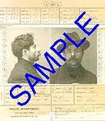
Figure 2: sample criminal record

Steganography
Steganography applications conceal information in other, seemingly innocent media. Steganographic results may masquerade as other file for data types, be concealed within various media, or even hidden in network traffic or disk space. We are only limited by our imagination in the many ways information and data can be exploited to conceal additional information.
For many years Information Hiding has captured the imagination of researchers. Digital watermarking and steganography techniques are used to address digital rights management, protect information, and conceal secrets. Information hiding techniques provide an interesting challenge for digital forensic investigations. Information can easily traverse through firewalls undetected. Research into steganalysis techniques aids in the discovery of such hidden information as well as leads research toward improved methods for hiding information.
Related research themes include: anonymous communications, anonymous online transactions, covert channels in computer systems, covert/subliminal communications, detection of hidden information (steganalysis), digital forensics, information hiding aspects of privacy, steganography, subliminal channels in cryptographic protocols, watermarking for protection of intellectual property, and other applications.
Zip and unzip
Many sources of information contain redundant data or data that adds little to the stored information. This results in tremendous amounts of data being transferred between client and server applications or computers in general. The obvious solution to the problems of data storage and information transfer is to install additional storage devices and expand existing communication facilities. To do so, however, requires an increase in an organization's operating costs. One method to alleviate a portion of data storage and information transfer is through the representation of data by more efficient code. This article presents a brief introduction to data compression and decompression, and shows how to compress and decompress data, efficiently and conveniently, from within your Java applications using the java.util.zip package.
While it is possible to compress and decompress data using tools such as WinZip, gzip, and Java Archive (or jar), these tools are used as standalone applications. It is possible to invoke these tools from your Java applications, but this is not a straightforward approach and not an efficient solution. This is especially true if you wish to compress and decompress data on the fly (before transferring it to a remote machine for example). This article:
- Gives you a brief overview of data compression
- Describes the java.util.zip package
- Shows how to use this package to compress and decompress data
- Shows how to compress and decompress serialized objects to save disk space
- Shows how to compress and decompress data on the fly to improve the performance of client/server applications
There are many benefits to data compression. The main advantage of it, however, is to reduce storage requirements. Also, for data communications, the transfer of compressed data over a medium results in an increase in the rate of information transfer. Note that data compression can be implemented on existing hardware by software or through the use of special hardware devices that incorporate compression techniques. Figure 1 shows a basic data-compression block diagram.
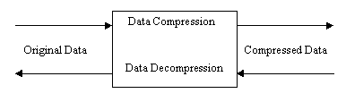
Figure 1: Data-compression block diagram

Minutiae based fingerprint algorithms
Minutiae-based method is the most popular approach in fingerprint matching. However, most existing methods need to search for the best correspondence of minutiae pairs or use reference points (core and delta points) to estimate the alignment parameters. The problem of lost minutiae or spurious minutiae always occurs during the minutiae detection process. Hence, the corresponding pairs or reference points may not be found under this condition. This paper proposes a new minutiae-based fingerprint matching algorithm using phase correlation. We define a new representation called Minutiae Direction Map (MDM). First, we convert minutiae sets into 2D image spaces. Then the transformation parameters are calculated using phase correlation between two MDMs to align two fingerprints to be matched. The similarity of two fingerprints is determined by the distance between two minutiae sets. Our approach does not need to search for the corresponding minutiae pairs. Experimental results show that the proposed approach performed well in matching fingerprint minutiae sets, which greatly improved the economy of storage space.

7. OUTPUT SCREENS

Login Page

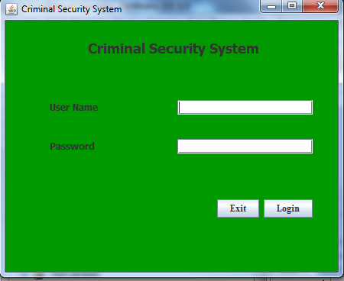

Home Page:
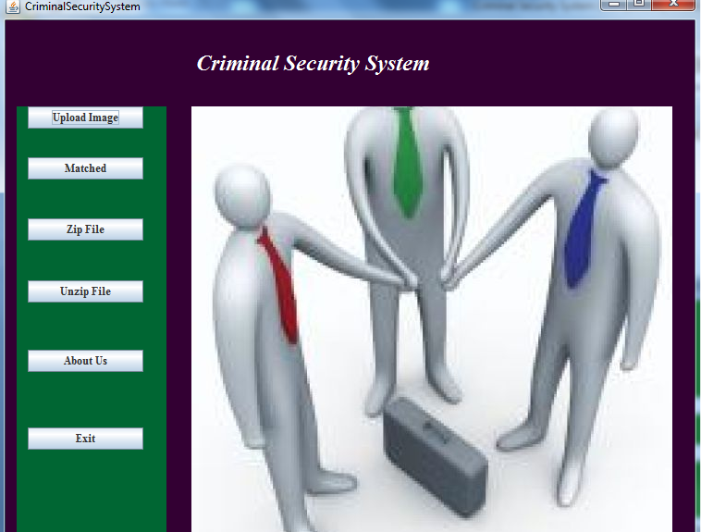

Upload Record:
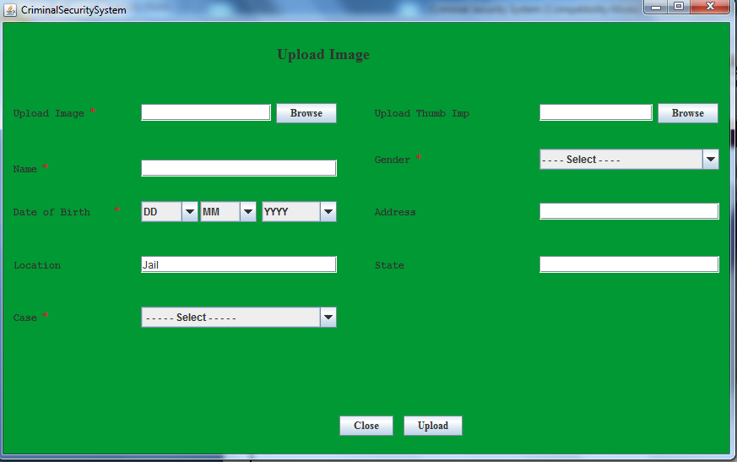
Match Record:

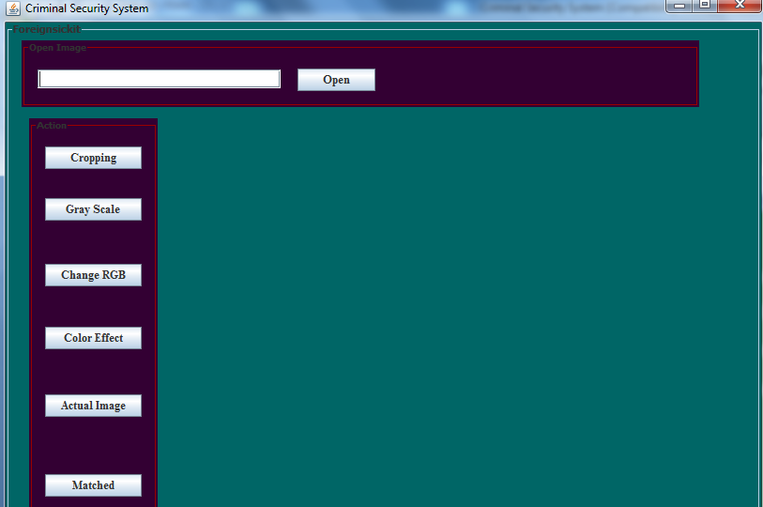
Zip Record:
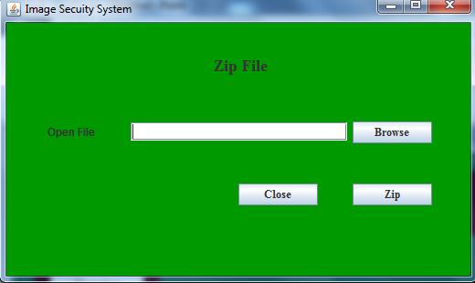
Upzip Record:
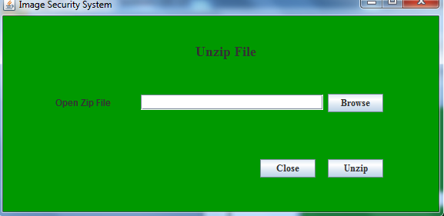

Stanografhy
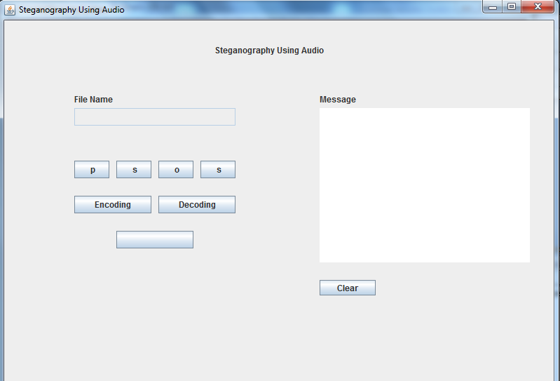

8.SCOPE OF THE SOLUTION

The project Criminal Security System is all about criminal clue. In this project first of all we capture the picture then we will open the clue in this software. We can perform the lot of task on this clue like cropping, gray scale, change RGB, color effect, actual image and matched. You can search the user details which are store in database.
In this project extra feature you can hide the message in picture. The main concern of this project is to improve the efficiency and effectiveness of the whole system.

9.Research and methodology
In this project there is agent module agent. First of all Agent have to upload basic information of criminal with their thumb impression .Whenever we have to search details of criminal then we can search criminal with their record. We can also check criminal record with their thumb impression. There are one extra feature included in my project i.e. Steganography We can hide data using Audio Steganography so that the chances of data hiking may reduces. One more feature in this project that we can also zip or Unzip Notepad file (Only Txt file) .Now if agent want to send images with signature to minister then he can do this using image watermarking in a secure way.
Minutiae based fingerprint algorithms require highly accurate templates for enrollment. Many fingers are difficult to enroll due to issues in race, sex, age, and occupation . Moreover, obtaining quality templates in a non-perfect world of poor image quality and application ergonomics can require multiple attempts by trained and untrained users. In a consumer based model, this can lead to increased support costs, costs of sales, and user resistance to technology acceptance.

10.FUTURE SCOPE AND ENHANCEMENT

The Image security system can be used in forensic lab, or other detective agency, organization’s etc. as a step towards security implementation’s. The server and client base Architecture for secure communication and data hiding in secure way any organization’s database and check unauthorized access to data.
ENHANCEMENTS:
- Video or audio water marking’s of the client’s window for non-repudiation.
- Used for troubleshoot any upcoming problem.
- Used to find statistics of host.
- To hold conversation between two different IP address.
In future, we can have the integrate the real time picture and bio metric device for finger print scan system facility for the criminal and criminal search engine that can provide the result on the basis of different criteria to search. We can also have one more module of implementing this project on this application.

11.CONCLUSION

Over all this application is very safe. In this Criminal Security System is a application which is used for defance deparment.In this application admin can upload the details of criminal with his thumb impression and his basic contact details in the database.In Future if anywhere any activity is happened then admin take that place’s thumb impression and through this he can search the regarding criminal records.In this application admin can also hide important infromation using the latest technologies i.e. stanography.It is really very safe method.we have also include compression or decompression technique so that important data may be safe by attacing the virus. If image are not identify cleary then we use zoom,contrast etc method to clarify the image .

12.BIBILIOGRAPHY

- http://www.javaworld.com/javaworld/jw-01-1998/jw-01-bookreview.html
- Database Programming with JDBC and Java by O'Reilly
- Head First Java 2nd Edition
- http://www.jdbc-tutorial.com/
- Java and Software Design Concepts by APress.
References
- http://www.javaworld.com/javaworld/jw-01-1998/jw-01-bookreview.html
- Database Programming with JDBC and Java by O'Reilly
- Head First Java 2nd Edition
- http://www.jdbc-tutorial.com/
- Java and Software Design Concepts by APress
- http://code.google.com/p/imogene/wiki/ImogeneDemo
- www.wikepedia.com

